Women in Cardiology: Life and Career Coaching
January 28, 2023 | Miami, FL

Activity Overview
This session will help you discover who you are as a leader, define your goals, explore how to motivate others, define your vision, and include a session for addressing cultural and systemic challenges women in the workplace face, and create the strength and strategies to overcome both internal and external speed bumps.

Target Audience
This activity is designed for an audience of physicians.

Learning Objectives
Upon completion of the educational activity, participants should be able to:

- Create strategies to overcome cultural and systemic challenges women in the workplace face.
- Explore how to successfully motivate others.
- Define career and personal goals use the SMART system for measurable results.

Criteria for Success
Statements of credit will be awarded based on the participant's attendance. A statement of credit will be available upon completion of an online evaluation/claim credit form available at:

akhcme.com/FLACC

Please claim your credit by February 15, 2023.
If you have questions about this CE activity, please contact AKH Inc at JGoldman@akhcme.com.

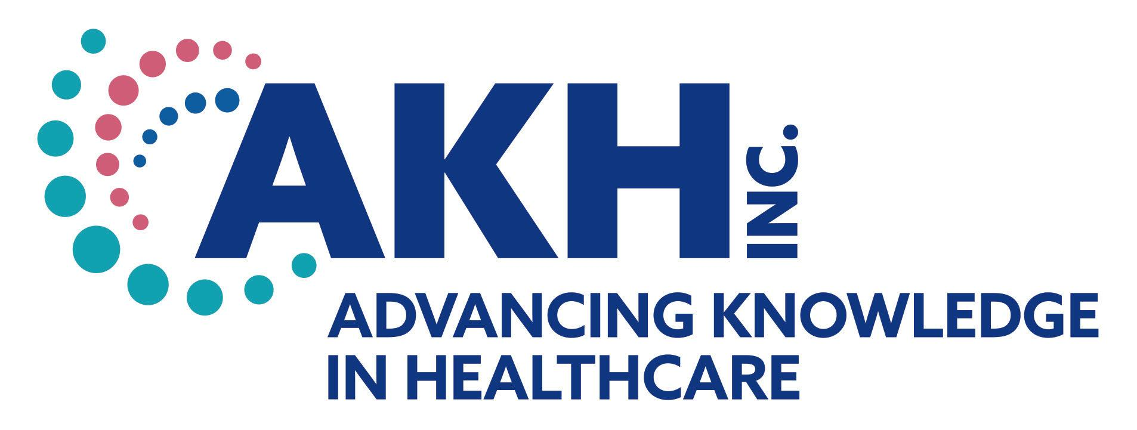
CE credit provided by AKH Inc., Advancing Knowledge in Healthcare.

In support of improving patient care, this activity has been planned and implemented by AKH Inc., Advancing Knowledge in Healthcare and Florida Chapter, American College of Cardiology. AKH Inc., Advancing Knowledge in Healthcare is jointly accredited by the Accreditation Council for Continuing Medical Education (ACCME), the Accreditation Council for Pharmacy Education (ACPE), and the American Nurses Credentialing Center (ANCC), to provide continuing education for the healthcare team.

Physicians
AKH Inc., Advancing Knowledge in Healthcare designates this live activity for a maximum of 3.0 AMA PRA Category 1 Credit(s)™. Physicians should claim only the credit commensurate with the extent of their participation in the activity.

Commercial Support
There is no commercial support for this activity.

DISCLOSURES
Name | Relationship | Commercial Interest
Katarzyna Niewiadomska, MS, PhD, CPCC, PCC (faculty) | N/A | Nothing to disclose
Dorothy Caputo, MA, BSN, RN, Senior Director of Continuing Education & Compliance | N/A | Nothing to disclose
Michele Bielarski, RN (planner/reviewer) | N/A | Nothing to disclose
AKH Inc Staff and Planners | N/A | Nothing to disclose
Florida Chapter, American College of Cardiology Staff and Planners | N/A | Nothing to disclose
All of the relevant financial relationships listed for these individuals have been mitigated.

Disclosures
It is the policy of AKH Inc. to ensure independence, balance, objectivity, scientific rigor, and integrity in all of its continuing education activities. The author must disclose to the participants any significant relationships with ineligible companies whose products or devices may be mentioned in the activity or with the commercial supporter of this continuing education activity. Identified conflicts of interest are mitigated by AKH prior to accreditation of the activity. AKH planners and reviewers have no relevant financial relationships to disclose.

Disclosure of Unlabeled Use and Investigational Product
This educational activity may include discussion of uses of agents that are investigational and/or unapproved by the FDA. Please refer to the official prescribing information for each product for discussion of approved indications, contraindications, and warnings.

Disclaimer
This course is designed solely to provide the healthcare professional with information to assist in his/her practice and professional development and is not to be considered a diagnostic tool to replace professional advice or treatment. The course serves as a general guide to the healthcare professional, and therefore, cannot be considered as giving legal, nursing, medical, or other professional advice in specific cases. AKH Inc. specifically disclaim responsibility for any adverse consequences resulting directly or indirectly from information in the course, for undetected error, or through participant&#39;s misunderstanding of the content.

