Clinical Essentials for the CVTeam
January 27-28, 2023 | Miami, FL

Activity Overview
This activity will explore the evolution of treatments in emerging subspecialties of cardiology in a team-based approach to care. The functions of the team in emerging fields such as cardiac amyloidosis, cardio-oncology, and cardio-obstetrics are just being defined. Find out the clinical issues patients face and how new treatments change the approach to evidence-based care.

Target Audience
This activity is designed for an audience of physicians, physician assistants, pharmacists, nurses and nurse practitioners.

Learning Objectives
Upon completion of the educational activity, participants should be able to:

Establishing A Cardiometabolic Disease Program - A Review of Patient Needs and Clinic Development - Ginger Biesbrock, DSc, PA-C, FACC
- Describe the reasons for starting a clinic within the practice and articulate the patient needs and the clinical skills and structure needed to fulfill them.

Digital Health - Asim Ahmed, DO, FACC, FHRS
- Choose the digital platforms that best suits the patient needs.

Post-partum Prevention of Complications from Hypertensive Disorders - Garima Sharma, MD, FACC
- Identify the prevention strategies that can lessen complications in post-partum women who has hypertensive disorders.

Cardiac Amyloidosis, An Infiltrative Disease: Rare or Not? - Jennifer Fox, MSN, RN-BC, ACNPC-AG, CCRN, CHFN
- Recognize amyloidosis and how to manage patients.

Cardio-oncology Updates: New Guidelines, Definitions, and Existing Collaborations - - Diego Sadler, MD, FACC
- Discuss and explain the newest research in cardio-oncology.

What's New in AFib - Litsa K. Lambrakos, MD, FACC
- Analyze the newest research and be able to formulate care plans based on the evidence-based research.

Criteria for Success
Statements of credit will be awarded based on the participant's attendance. A statement of credit will be available upon completion of an online evaluation/claim credit form available at:

akhcme.com/FLACC

Please claim your credit by February 15, 2023.
If you have questions about this CE activity, please contact AKH Inc at JGoldman@akhcme.com.

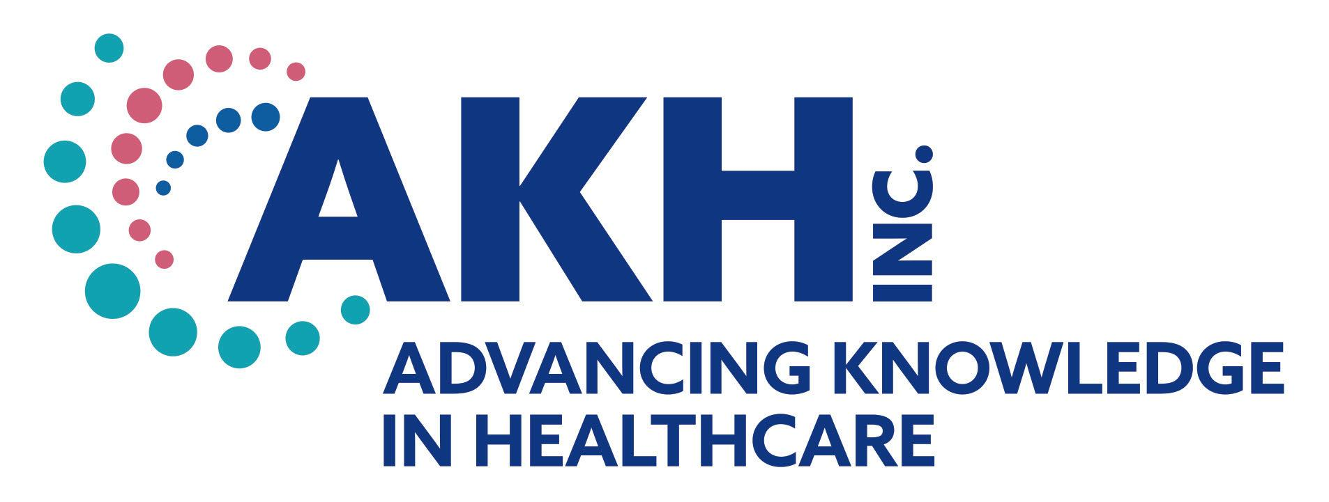
CE credit provided by AKH Inc., Advancing Knowledge in Healthcare.

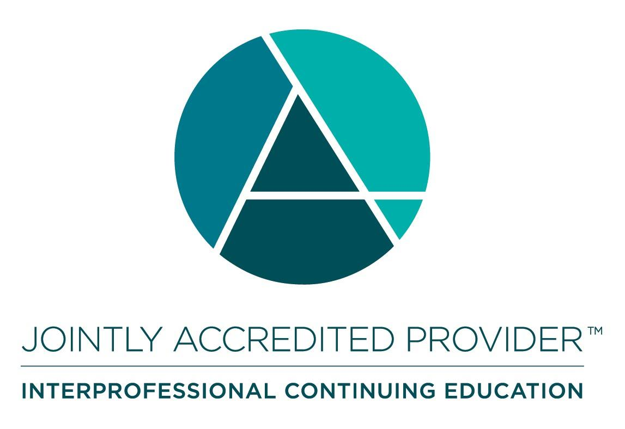
In support of improving patient care, this activity has been planned and implemented by AKH Inc., Advancing Knowledge in Healthcare and Florida Chapter, American College of Cardiology. AKH Inc., Advancing Knowledge in Healthcare is jointly accredited by the Accreditation Council for Continuing Medical Education (ACCME), the Accreditation Council for Pharmacy Education (ACPE), and the American Nurses Credentialing Center (ANCC), to provide continuing education for the healthcare team.

Physicians
AKH Inc., Advancing Knowledge in Healthcare designates this live activity for a maximum of 5.0 AMA PRA Category 1 Credit(s)™. Physicians should claim only the credit commensurate with the extent of their participation in the activity.

Nurses
Credit being awarded: 5.0 ANCC contact hours

Pharmacists
AKH Inc., Advancing Knowledge in Healthcare designates this continuing education activity for 5.0 contact hours.

Physician Assistant
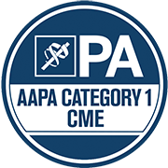
AKH Inc., Advancing Knowledge in Healthcare has been authorized by the American Academy of PAs (AAPA) to award AAPA Category 1 CME credit for activities planned in accordance with AAPA CME Criteria. This activity is designated for 5.0 AAPA Category 1 CME credits. PAs should only claim credit commensurate with the extent of their participation.

Nurse Practitioners
This activity has been planned and implemented in accordance with the Accreditation Standards of the American Association of Nurse Practitioners (AANP) through the joint providership of AKH Inc., Advancing Knowledge in Healthcare and Florida Chapter, American College of Cardiology. AKH Inc., Advancing Knowledge in Healthcare is accredited by the American Association of Nurse Practitioners as an approved provider of nurse practitioner continuing education. Provider number: 030803. This activity is approved for 5.0 contact hour(s) (which includes TBD hour(s) of pharmacology).

Commercial Support
There is no commercial support for this activity.

DISCLOSURES
Name | Relationship | Commercial Interest
Asim Ahmed, DO, FACC, FHRS (faculty) | N/A | Nothing to disclose
Ginger Biesbrock, DSc, PA-C, FACC (faculty) | N/A | Nothing to disclose
Jennifer Fox, MSN, RN-BC, ACNPC-AG, CCRN, CHFN (faculty) | N/A | Nothing to disclose
Litsa K. Lambrakos, MD, FACC (faculty) | Consultant | Medtronic LLC
Diego Sadler, MD, FACC (faculty) | N/A | Nothing to disclose
Garima Sharma, MD, FACC (faculty) | N/A | Nothing to disclose
Dorothy Caputo, MA, BSN, RN, Senior Director of Continuing Education & Compliance | N/A | Nothing to disclose
Bernadette Makar, MSN, APRN-BC, NP-C (planner/reviewer) | N/A | Nothing to disclose
Dorothy Duffy, RPh (planner/reviewer) | N/A | Nothing to disclose
AKH Inc Staff and Planners | N/A | Nothing to disclose
Florida Chapter, American College of Cardiology Staff and Planners | N/A | Nothing to disclose
All of the relevant financial relationships listed for these individuals have been mitigated.

Disclosures
It is the policy of AKH Inc. to ensure independence, balance, objectivity, scientific rigor, and integrity in all of its continuing education activities. The author must disclose to the participants any significant relationships with ineligible companies whose products or devices may be mentioned in the activity or with the commercial supporter of this continuing education activity. Identified conflicts of interest are mitigated by AKH prior to accreditation of the activity. AKH planners and reviewers have no relevant financial relationships to disclose.

Disclosure of Unlabeled Use and Investigational Product
This educational activity may include discussion of uses of agents that are investigational and/or unapproved by the FDA. Please refer to the official prescribing information for each product for discussion of approved indications, contraindications, and warnings.

Disclaimer
This course is designed solely to provide the healthcare professional with information to assist in his/her practice and professional development and is not to be considered a diagnostic tool to replace professional advice or treatment. The course serves as a general guide to the healthcare professional, and therefore, cannot be considered as giving legal, nursing, medical, or other professional advice in specific cases. AKH Inc. specifically disclaim responsibility for any adverse consequences resulting directly or indirectly from information in the course, for undetected error, or through participant&#39;s misunderstanding of the content.

